Name: Ahmed Tarek Mohamed EL-Meligy

Track: PHP

Red Hat Lab(2)

**1. Create a user account with the following attribute**

* username: islam

* Fullname/comment: Islam Askar

* Password: islam

**2. Create a user account with the following attribute**

* Username: baduser

* Full name/comment: Bad User

* Password: baduser

**3. Create a supplementary (Secondary) group called pgroup with group ID of 30000**



**4. Create a supplementary group called badgroup**



**5. Add islam user to the pgroup group as a supplementary group**

**6. Modify the password of islam's account to password**

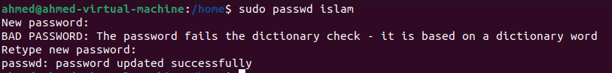

**7. Modify islam's account so the password expires after 30 days**



**8. Lock bad user account so he can't log in**



**9. Delete bad user account**



**10. Delete the supplementary group called badgroup.**



**13. Create a folder called myteam in your home directory and change its permissions to read only for the owner.**

**14. Log out and log in by another user**



**15. Try to access (by cd command) the folder (myteam)**



**16. Using the command Line**

**\* Change the permissions of oldpasswd file to give owner read and write**

**permissions and for group write and execute and execute only for the others**

**(using chmod in 2 different ways)**

**_____________________________________________________________________________________**

**\* Change your default permissions to be as above.**



**\*** What is the maximum permission a file can have, by default when it is just created? And what is that for directory.

For a File the maximum permission it can have is ( 666 ) or ( rw rw rw )

For a directory the maximum permission it can have is ( 777 ) or ( rwx rwx rwx )

* Change your default permissions to be no permission to everyone then create a directory and a file to verify.

**17. What are the minimum permission needed for:**

**\* Copy a directory (permission for source directory and permissions for target**

**parent directory)**

**Source directory: it need ( r-- ) read permission only**

**Target directory: it need ( rwx ) read , write and execute  
_____________________________________________________________________________________**

**\* Copy a file (permission for source file and and permission for target parent**

**directory)**

**Source file: it need ( r-- ) read permission only**

**Target directory: it need ( rwx ) read , write and execute**

**\*** Delete a file

It needs ( -wx ) write and execute

* Change to a directory

It needs ( --x ) execute

* List a directory content (ls command)

It needs ( --x ) execute

**\*** View a file content (more/cat command)

It needs ( r-- ) read

**\*** Modify a file content

It needs ( -w- ) write

**18. Create a file with permission 444. Try to edit in it and to remove it? Note what**

**happened.**

Since its read only file , I don’t have permission to delete or edit the file it will show an error

**19. What is the difference between the “x” permission for a file and for a**

**directory?**

**For the file: it allows the file to run as a program .**

**For the directory: it allows the user to get access to it.**